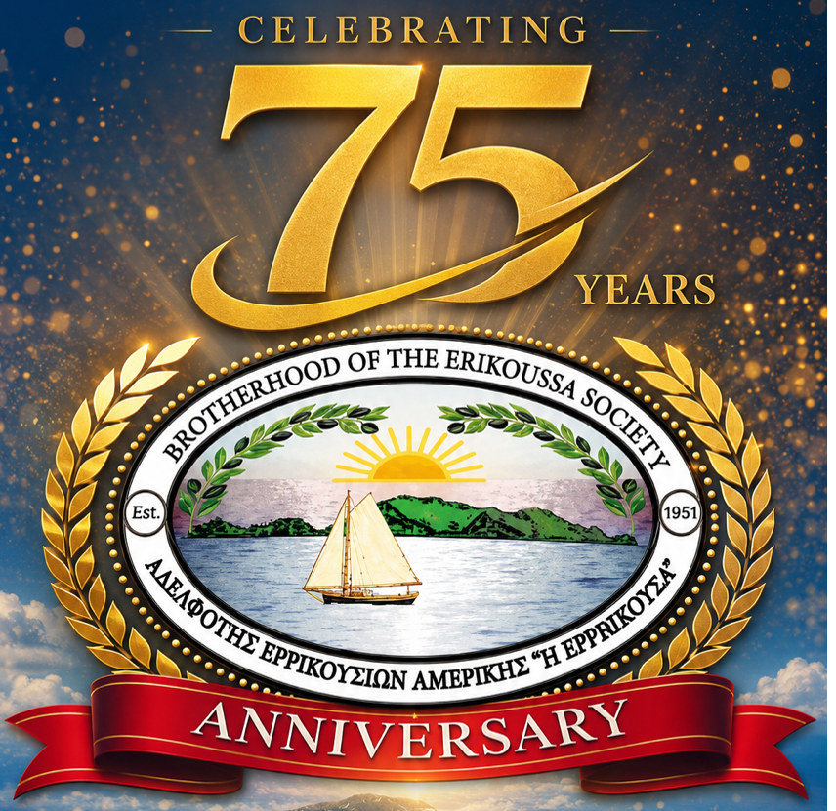
Brotherhood of the Erikoussa Society
75th Anniversary Gala Event • Saturday, November 28, 2026
Marina del Rey • Throggs Neck, New York
COMMEMORATIVE JOURNAL ADVERTISEMENT FORM
Our commemorative journal supports the organization’s mission and future goals.
Celebrate this milestone with a journal donation in one of the following forms:
Business Ads • Congratulatory Messages • Family Tributes • Memorial Dedications • Sponsor Acknowledgements

Your contribution to the 75th Gala Journal helps preserve and strengthen our organization for future generations.

The President, Board Members, and 75th Gala Chair Committee thank you for your support.

AD SIZES & PRICING
Ad Type | Price
Full Page | $500.00
Half Page | $300.00
Premium Ad Pages
Inside Front Cover |  | $1,500.00
Inside Back Cover |  | $1,500.00
Outside Back Cover |  | $2,000.00

ADVERTISER INFORMATION
Organization/Company: ____________________ Contact Name: ____________________ Title: ____________________
Address: ______________________________________________ City: __________________ State: ______ Zip: __________
Phone: __________________ Email: ______________________________________________

AD INFORMATION
Ad Size (select one): ☐ Full Page ☐ Half Page ☐ Business Card Amount Enclosed: $__________________
Message/Instructions: ____________________________________________________________________________________

AD SUBMISSION
Submit artwork (print-ready PDF preferred) by email or upload link. Email: ______________________________ Upload Link: ______________________________

PAYMENT INFORMATION
☐ Check Enclosed (Payable to __________________) ☐ Cash ☐ Credit Card
Name on Card: __________________ Card Number: __________________ Exp. Date: ______ CVV: _____ Zip: _____ Signature: __________________

DEADLINE
All ad materials and payments must be received by Thursday, October 15, 2026.

SEND FORM & PAYMENT TO
Miss Maria Katehis, Attn: 75th Gala Chair Committee, 3170 Spencer Drive, Bronx, NY 10465, Phone: (917) 767-9292, Email: mkatehis@verizon.net
Thank you for celebrating 75 years with us.

